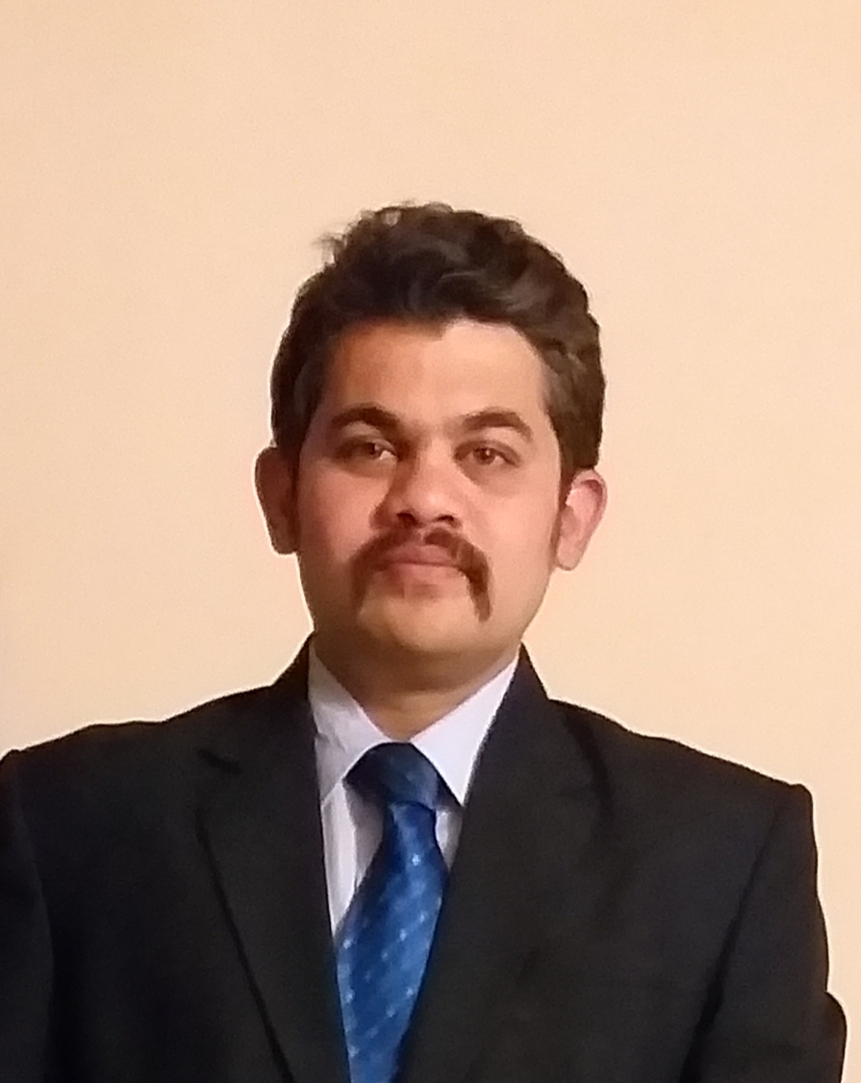

Name: Sukrut Patwardhan

Cell No: 9850987541

Email id: sukrutlifecoach@gmail.com

Career Objective

"Seeking an entry-level position in the IT industry where I can utilize my technical skills, problem-solving abilities, and passion for innovation. Eager to work in a dynamic environment, learn new technologies, and contribute to the success of the organization while continuously growing as a professional."

Work Experience

Organization: Accenture (Payroll – Manpower Group)
Duration: Sept 2018 to May 2019
Designation: VBA and RPA (AA) Developer

Key responsibilities:

- Analysed business requirement and prepare business requirement and solution design document
- Designed, developed and deployed end to end process automation
- Testing an application in UAT and fix the bugs if any
- Modification of existing application in case of any changes/additional requirement from clients
- Meeting project deadline and quality with accuracy

Summer Internship Project

Company: The Smart bridge
Project Title: Identifying Marketing Strategies for ‘The Smart bridge’
Duration: June 2019 – Aug 2019

Description:
- Increase the students base of the company and to promote the brand
- Successfully contacted colleges, students and was able to generate the revenue for the company
- Had an opportunity to work with overseas client, learnt how to approach the client and effectively market the services of the company

Project Details

Company: Ardent Computech Pvt. Ltd.
Project Title: ‘Save Me’
Duration: April 2018 – June 2018

Description of the Project:
- Developed the software and programming the Java codes in ECLIPSE
- As a part of Project, we developed and implemented GPS Tracking application which is used in to log and track the details of GPS systems

Technical skills

Programming Languages: Python, Java, C++, JavaScript
Web Development: HTML, CSS, JavaScript, React.js, Node.js
Database Management: MySQL, PostgreSQL, MongoDB
Operating Systems: Windows, Linux (Ubuntu, Red Hat)
Cloud & DevOps: AWS, Docker, Kubernetes, Git, CI/CD

Educational Qualifications

B.E.: Successfully completed Engineering in Electronics and Telecommunication with 68.78%
Diploma: Completed HSC from BVJNIOT with 66% in science specialization (2001 - 2004)
SSC: Completed 10TH from New English School with 66.16% (2000)

Key Skills
  - Leadership skills
  - Effective Communication
  - Analytical skill
  - Creative thinking and innovation

Certifications

- Internationally certified Soft Skills Training certification pebbles hills university (USA)
- ICF certified coach from symbiosis university (USA)
- NLP trainer and Certified learning and development manager from Carlson University (USA)

Personal Details

Date of Birth: 14/09/1985

Languages Known: English, Hindi, Marathi

Permanent Address: 656 pratibha nagar near raut baug Dhankawadi 411043

